Research Memo: FreeRTOS Write-Up
CK Gallegos Rodriguez
1/23/2026

Purpose:
The purpose of incorporating an operating system into the project is to allow higher flexibility when programming the simulation. The two main reasons for choosing FreeRTOS are because we need to
- Have the ability to schedule tasks.
- Have a file system to write and read from the SD card.

An example of a configuration file is provided in FreeRTOS/FreeRTOS/Source/examples/template_configuration/FreeRTOSConfig.h. This version of the file has some much more useful comments that come with each definition. Also see the FreeRTOS book for reference.

Original Setup
There are a few things that you should know about the original project. First, to compile and flash code onto the FPGA board, one had to modify the file gpio_mgmt.c located in Caravel_NPU_FPGA_2025/caravel_mgmt_soc_litex/verilog/dv/tests-caravel/gpio_mgmt.
To compile the code, enter the directory above and run “make hex.” A hex file, gpio_mgmt.hex should be generated within that directory. The Makefiles for this command are located under Caravel_NPU_FPGA_2025/caravel_mgmt_soc_litex/verilog/dv/make. The makefiles describe the following:
- cpu.makefile – defines pathfiles to the source files, verilog files, and linker script. In this makefile, the block at line 30 will be executed.
- env.makefile – defines the paths to the gcc compiler. It is important that the .bashrc file contains the following exports
  - export DESIGNS='/home/<user>/<ROOT_FOLDER>'
  - export TOOLS='/opt/riscv'
- var.makefile – contains several necessary flags that specify our type of architecture (e.g. riscv) and the application binary interface (ABI) to be used. I added
- sim.makefile – this is the big actual makefile that compiles and builds the user program; it contains the rules and targets, and it uses the flags and paths defined in the other files above.
Once the hex file has been generated, check to make sure are no strange lines (see the README of the original repository, Process Flow Steps).
Note: If you ever try to run “make hex” and get an error along the lines of “No such file or directory”, I recommend printing some filepaths to the console using $(info …). For example:
$(info The filepath VERILOG_PATH is set to: $(VERILOG_PATH))

Changes Made to Original Setup
The first change made to the original repository was pulling the FreeRTOS repository into the project. In the Caravel_NPU_FPGA_2025 project, run the following:
git clone https://github.com/FreeRTOS/FreeRTOS.git --recurse-submodules
You can read more about the structure of the FreeRTOS repository in the book “Mastering the FreeRTOS Real Time Kernel” located under Caravel_NPU_FPGA_2025/Documents.
To achieve use of FreeRTOS libraries and headers, the following changes were made to the makefiles.
- In var.makefile, a FreeRTOS path was defined (FREERTOS_PATH), and a list of source files to be compiled was defined (FREERTOS_SRC). The source files include files for basic FreeRTOS functionality, such as tasks.c, queue.c, etc.
- In sim.makefile, added lines
-I$(FREERTOS_PATH)/Source/include \
-I$(FREERTOS_PATH)/Source \
-I$(FREERTOS_PATH)/Source/portable/GCC/RISC-V \
-I$(FREERTOS_PATH)/Source/portable/GCC/RISC-V/chip_specific_extensions/RISCV_no_extensions \
These make sure the compiler knows where the FreeRTOS source files are. The last two lines above point to the port we are using. See the book for more details.
- Copied a version of FreeRTOSConfig.h into Caravel_NPU_FPGA_2025/caravel_mgmt_soc_litex/verilog/dv/firmware. This is the overall configuration file for FreeRTOS. See the book for more details or see FreeRTOS/FreeRTOS/Source/example/template_configuration/FreeRTOSConfig.h. This version of the configuration header file is well-documented and contains blocks of comments dedicated to explaining what each definition means.

Note: In general, any header files needed need to go in this directory. Any files in this directory are included by the makefile.
Next, mem_helpers.c was added under FreeRTOS/FreeRTOS/Source. mem_helpers.c implements a simple version of memcpy() and memset(). This was necessary because many of the FreeRTOS source files use memcpy and memset. Normally, a flag in the makefile would specify to include all standard libraries in the compilation, but was explicitly disabled in the original system. Online sources say that including the full C library does not work well with bare metal applications. The recommended approach was simply implementing memcpy() and memset().
The errors received were the following:
/opt/riscv/lib/gcc/riscv32-unknown-linux-gnu/15.1.0/../../../../riscv32-unknown-linux-gnu/bin/ld: /tmp/ccGWuAbe.o: in function pvPortCalloc': /home/gallegck/CAPSTONE/Caravel_NPU_FPGA_2025/FreeRTOS/FreeRTOS/Source/portable/MemMang/heap_4.c:446:(.text+0x44c): undefined reference to memset'

Finally, the following error was encountered:
/opt/riscv/lib/gcc/riscv32-unknown-linux-gnu/15.1.0/../../../../riscv32-unknown-linux-gnu/bin/ld: gpio_mgmt.elf section `.bss' will not fit in region `dff'
/opt/riscv/lib/gcc/riscv32-unknown-linux-gnu/15.1.0/../../../../riscv32-unknown-linux-gnu/bin/ld: region `dff' overflowed by 1104 bytes
To fix this, the sections.lds file in Caravel_NPU_FPGA_2025/caravel_mgmt_soc_litex/verilog/dv/firmware had to be modified. The dff region had to be increased to fit the sections. Modify lines 13 and 14 to fit the .bss region.
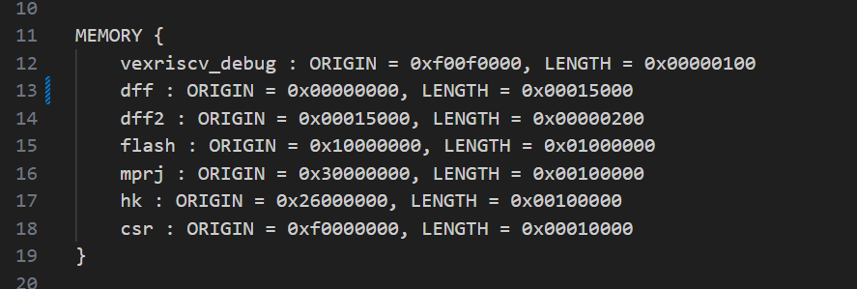
Note: I don’t know how this performs or what this affects. This was just a fix that got it to compile.

Moving Forward
Note: I have not tried actually flashing this code onto the board. Currently, the goal is to blink an LED using a FreeRTOS task.

If it becomes necessary to create custom header files or add more header files to the project, add these header files to the Caravel_NPU_FPGA_2025/caravel_mgmt_soc_litex/verilog/dv/firmware directory.
To modify the FreeRTOS configuration file, edit the FreeRTOSConfig.h file in the firmware folder. Read the book for more details on how to configure and use FreeRTOS.
Note: We have not yet tried reading to and from the SD card from FreeRTOS. It may be necessary to set up FreeRTOS+FAT32. The instructions should be the same as setting up FreeRTOS, I hope. However, this would entail pointing to a different repo. Look at the FreeRTOS main page for this.
Note: Incorporating FreeRTOS into the project resulted in the hex file growing from 12 MB to 137 MB approximately. Keep an eye on this, I don’t know how much flash memory we have.

